
November Meeting

When: Wednesday, November 15, 2000, 4:00 PM

Where: Northrop-Grumman

Ryan-Aeronautical Center (RAC)
17066 Goldentop Rd., Bldg. #2

San Diego, CA 92150 (map on pg. 2)

Hosts: Doug Fronius, Director, Tactical UAV Programs, (RAC)
Mike Donahoo, Director, Business Development, TAMSCO

Program:
RAC and TAMSCO are co-hosting the meeting at the new RAC facility in Rancho Bernardo, including a tour of the new home of the Global Hawk and Fire Scout (VTUAV) programs.
Maj. Gen. David Gust, USA (ret), TAMSCO’s new President/CEO is scheduled as the guest speaker. Gen. Gust has an extensive UAV background and will provide insight into past and current Army programs.
As Always, ITEA and INCOSE members are welcomed.

Agenda: (approximate)

4:00-4:15 Welcome, AUVSI Admin. (Mike/Steve)
4:15-4:30 RAC Introduction (Doug)
4:30-5:00 Gen. Gust briefing
5:00-6:00 Plant tour (Doug)
6:15-6:30 Wrap-up, adjourn

Light refreshments will be served

RSVP: Steve Coblentz, email: sccz@yahoo.com (Tel 619-561-0702, 858-292-3073)
Mike Donahoo, email: mrdonahoo@ixpres.com (Tel 619/437-8395, 619/701-8372)

AUVSI Web: http://www.AUVSI.org

Lindbergh Chapter: http://uvsnet.tripod.com

Note: (It’s a good idea to allow 30-40 min. from downtown due to
normal heavy traffic on I-15 North)
Directions:
Get to I-15 North from Whaere you are, then:
1. | Take the I-15 NORTH
2. | Proceed to Rancho Bernardo area, past Poway Rd and Carmel Valley Rd. | 9.6
3. | Take the CAMINO DEL NORTE exit. | 0.3
4. | Turn LEFT onto CAMINO DEL NORTE. | 1.5
5. | Turn SLIGHT RIGHT onto ramp. | 0.2
6. | Turn RIGHT onto CAMINO SAN BERNARDO. | 0.4
7. | Turn LEFT onto COASTWOOD RD. | 0.2
8. | Turn RIGHT onto GOLDENTOP RD. | 0.1

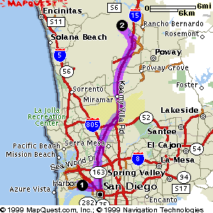
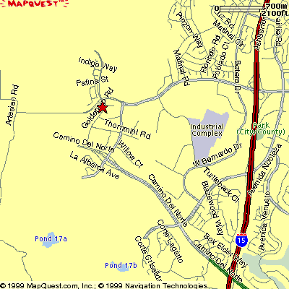
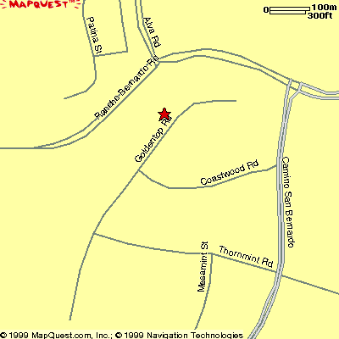
Northrop-Grumman
Ryan Aeronautical Center
17066 Goldentop Rd

